A TECHNICAL REPORT ON STUDENT’S INDUSTRIAL WORKS EXPERIENCE SCHEME (SIWES)

TITLE PAGE

AT
ASADA CONTRACTORS LTD,
NASARAWA, KANO STATE

FROM: 7TH OCTOBER, 2024
TO: 7TH FEBRUARY, 2025

BY
AYUBA AMOS
(ET/CE/ND/23/016)

THIS TECHNICAL REPORT IS SUBMITTED TO THE DEPARTMENT OF CIVIL ENGINEERING TECHNOLOGY, IN PARTIAL FULFILLMENT OF THE REQUIREMENT FOR THE AWARD OF NATIONAL DIPLOMA (ND) IN CIVIL ENGINEERING TECHNOLOGY, FEDERAL POLYTECHNIC, MUBI.

MARCH, 2025

DEDICATION
This work is dedicated to God Almighty the maker of heavens and Earth, the giver of life and wisdom and to my beloved parents and all my family members who work hard to support me.

ACKNOWLEDGEMENTS
I wish to acknowledge God Almighty for his infinite goodness, mercy and protection over my life through this training and professional program at large.
In official way I wish to acknowledge my beloved parents for her loving and wonderful support over the phase of the event and my beloved brothers and sisters and all my family members and friends who work hard in contact to support and ensure that he program is rated successfully and I pray that may God in his infinite mercy, guide, bless, enrich, protect and support them in the ways of their life and health status, likewise financially encounter them with supernatural break through in all phase of life.
I also wish to acknowledge my SIWES supervisor Engr. Ngura Yahya Kowagol and SIWES Coordinator in person of Engr. Sunu Jude for their effort ensuring the success of the industrial training programme.
I faithfully, acknowledge my Honourable Head of Department in person Engr. Yakubu Mammad and all the staff of Civil Engineering department together with my fellow course mates for their support to enhance this training a successful one. I pray that may God continue to bless and support them financially, academically throughout their life time. Amen.

ABSTRACT
This technical report is based on the experiences acquired during a four-month industrial attachment. It comprehensively documents all aspects of the training period. Chapter One provides an overview of the Industrial Training Fund (ITF), highlighting its history, benefits, aims, and objectives, as well as a brief history of the organization where the training was conducted. Chapter Two introduces the site work activities, including dampproof laying, excavation, and column casting. Chapter Three details the processes of blinding, casting, block work, drainage construction, reinforcement, and the use of working drawings on site. Finally, Chapter Four presents the conclusion and recommendations based on observations during the attachment, followed by the references.

TABLE OF CONTENT
TITLE PAGE i
DEDICATION ii
ACKNOWLEDGEMENTS iii
ABSTRACT iv
TABLE OF CONTENT v
CHAPTER ONE 1
1.0 INTRODUCTION 1
1.1 MEANING OF ITF 1
1.2 OBJECTIVE OF ITF 1
1.3 AIM OF ITF 2
1.4 MEANING OF SIWES 2
1.5 OBJECTIVES OF SIWES 2
1.6 AIM OF SIWES 3
1.7 SIGNIFICANCE OF SIWES 3
1.8 HISTORY OF THE ORGANIZATION 4
1.9 ORGANIZATIONAL STRUCTURE 5
CHAPTER TWO 6
EXPERIENCE GAINED DURING TRAINNG 6
2.1 INTRODUCTION TO SITE 6
2.2 LAYING OF DAM PROOF 6
2.2 EXCAVATION 9
2.3 COLUMN CASTING 10
CHAPTER THREE 12
3.1 BLINDING 12
3.2 CASTING 13
3.3 BLOCK WORK 15
3.4 CONSTRUCTION OF DRAINAGE REINFORCEMENT 17
3.5 WORKING DRAWING ON SITE 20
CHAPTER FOUR 22
CONCLUSION AND RECOMMENDATIONS 22
4.1 CONCLUSION 22
4.2 RECOMMENDATIONS 22
REFERENCE 23

CHAPTER ONE

1.0 INTRODUCTION
The Student’s Industrial Work Experience Scheme (SIWES) is a skill training programme designed to expose and prepare students in institution of higher learning.
This skill is also meant to expose students to working manner of some organization in the country and give them the required experience and practical to know how to handle equipment and machinery that may not be found in their institution.
The SIWES programme is finance by the Federal Government of Nigeria through the industrial training Fund (ITF) board. In most case, the capital used is partially obtained from taxing the registered companies and the federal government donated the remaining funds. The SIWES as a cooperation between industrial and institutional of higher learning in Nigeria is a continuation of student studies.

1.1 MEANING OF ITF
The industrial training fund was established by the decree No. 47 of 8th October 1971, with the aim of promoting and encouraging skills and acquisition of skills in industrial and commerce with a view of generate a pool of indigenous manpower to meet the need of the economy of the country.

1.2 OBJECTIVE OF ITF
- Building of training facilities of its own in identified area of national need.
- The establishment of uniform national vocation and apprenticeship training scheme in the country.
- Bearing a proportion of direct cost of the Job and off-job training Nigeria employees.
- Organizing research students as support to other activities of the fund.
- Seeking the harmonized ITF, no formal training programme with the curricular formal education institution.

1.3 AIM OF ITF
The aim of ITF is for promoting and encouraging the requisition of skills in industrial and commerce with a view to generate a pool of indigenous trained manpower and sufficient to meet the need of the economy.

1.4 MEANING OF SIWES
The programme SIWES is the student industrial work Experience Scheme which is coordinated by the industrial training fund (ITF).
The scheme helps the students to be exposed to the practical knowledge that he might not get in school during his course of study.

1.5 OBJECTIVES OF SIWES
- To expose student to equipment practically.
- To provide knowledgeable and efficient graduates under each related field
- To increase the number of skilled workers
- To bring cooperation between the employer and the estuation so as to work hand enhanced and to know what type of student to be produced and to what extent.
- To enable the students, practice their profession even after school, not only at working level even personally.

1.6 AIM OF SIWES
- To help student to see practically what have been taught earlier in classroom.
- To reconcile theory work with that of practical.
- To enable students to practically take part in ensure greats production.
- To help student greatly to know the rule and regulation and procedure of the work.

1.7 SIGNIFICANCE OF SIWES
- It helps student to gain job experience in life
- It provides an opportunity to student to pulling human relation forest by exposing students to actual working environment.
- It helps student to be skilled and knowledgeable in handling industrial equipment and tool.
- It helps students to apply principle taught in school successful on job assign to him/her.

1.8 HISTORY OF THE ORGANIZATION
ASADA CONTRACTORS LTD, based in Nasarawa, Kano State, was founded by Engr. Abubakar Aisar with a vision to provide top-tier construction services tailored to the region’s growing infrastructural needs. Established in 2005, the company started with humble beginnings, driven by Engr. Aisar’s expertise in civil engineering and his dedication to community development. Over the years, ASADA CONTRACTORS LTD has built a reputation for delivering high-quality projects that contribute to the economic and social advancement of Kano State and beyond.
The company offers a comprehensive range of services, including architectural design, civil engineering, construction, project management, renovation, infrastructure development, sustainable building solutions, consultancy, interior fit-out, and landscaping. Their architectural services cover conceptualization, drafting, 3D modeling, and interior design, ensuring functional and aesthetically pleasing structures. ASADA CONTRACTORS LTD specializes in civil engineering solutions, providing expertise in structural and foundation design, site planning, and road construction to meet the demands of both public and private sector projects.
With a commitment to innovation, quality, and sustainability, ASADA CONTRACTORS LTD continues to be a trusted name in the construction industry, shaping the built environment in Kano State and beyond.

1.9 ORGANIZATIONAL STRUCTURE
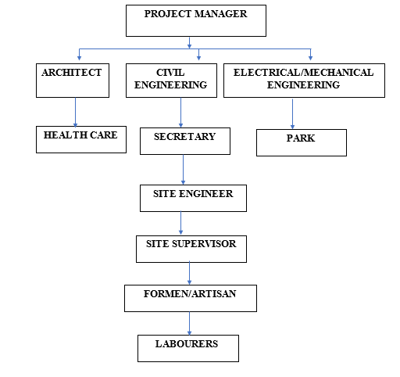

Figure 1.1: Organizational Chart

CHAPTER TWO

EXPERIENCE GAINED DURING TRAINNG

2.1 INTRODUCTION TO SITE
A site is a place of construction where the work is undertaken, it is usually associated with engineering work.

2.2 LAYING OF DAM PROOF
Dam proofing is a critical aspect of construction, especially in structures where water ingress poses a significant threat. The implementation of a Dam Proof Course (DPC) and a Dam Proof Membrane (DPM) is essential to prevent water seepage and dampness within buildings. This report outlines the process and significance of laying DPC and DPM in construction projects. The primary purpose of laying a Dam Proof Course and Dam Proof Membrane is to provide a barrier against moisture penetration. This prevents dampness, mold growth, and structural deterioration, thereby ensuring the longevity and integrity of the building.
Materials Used
Dam Proof Course (DPC): Typically made of materials such as bitumen, EPDM (Ethylene Propylene Diene Monomer), PVC (Polyvinyl Chloride), or other synthetic compounds, Available in rolls or sheets, Resistant to water penetration.
Dam Proof Membrane (DPM): Often composed of polyethylene or bituminous materials, Available in rolls, Provided an impermeable layer against moisture.
Procedure
- Ensured the surface was clean, dry, and free from debris.
- Cut the DPC material into appropriate lengths according to the dimensions of the area to be covered.
- Laid the DPC horizontally at the base of the walls, ensuring it overlapped at joints and corners.
- Used an adhesive or mortar to fix the DPC securely in place.
- Ensured proper bonding with the substrate to prevent any gaps or air pockets.
- Rolled out the DPM material over the entire surface area, ensuring sufficient overlap between adjacent sheets.
- Secured the DPM at the edges and joints using adhesive or tape.
- Inspected the installed DPC and DPM for any tears, gaps, or imperfections.
- Prevented water seepage through walls and foundations, thereby preserving the structural integrity of the building.
- Enhanced the durability and lifespan of the building by protecting it from water damage.
- Recommended regular maintenance and inspection of DPC and DPM to address any wear and tear promptly.

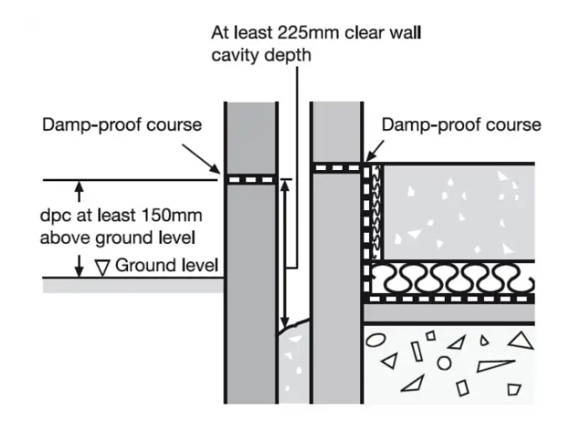

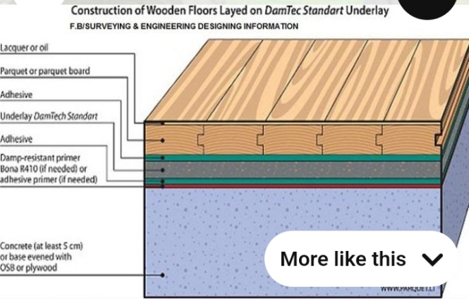

Plate 3.1: Diagram showing DPC and DPM

2.2 EXCAVATION
Excavation is the loosing and removal of earth or rocks from its original position, and transporting it to spoiled bank. It was done immediately after setting out. The excavation was done by an excavator and the drainage trench was dug to a depth of 1000mm and a width of 1000mm. Excavation can be done using two methods mechanical and manual. In small construction we normally use manual method while in large construction we use mechanical e.g. like road construction.
Excavation work were carried out manually where unskilled labourer where involved with digger, shovels, head pan and wheel barrow. The following factors must be considered when carrying out any excavation work.
- Nature of the soil
- The width and depth of foundation
- Climatic condition at the time of excavation
- The water table of the soil
- The period excavation work is expected to be left open.
- The effect of excavation on existing adjacent structure.

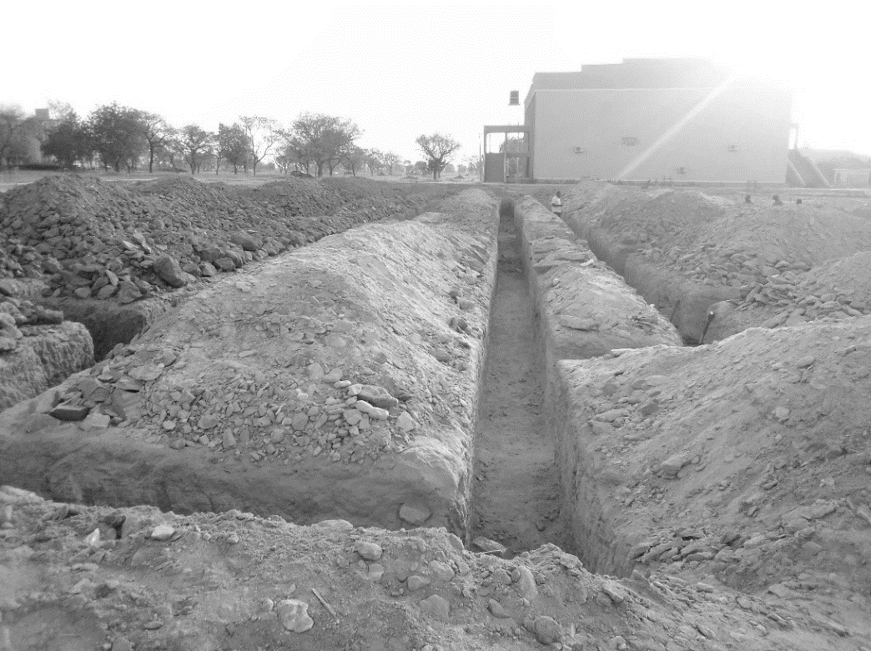

Plate 3.2: Excavation
Source: Author’s work, 2023

2.3 COLUMN CASTING
We usually tie our rope to out or in-to-in and then place our pillar in the middle of the block to make it align and in straight line.
After putting the baskets in their respective positions, the pillars are then set with the ropes (crossed in between the ropes). Then we made sure that the pillar is not touching the rope, and then tied it to the basket with the blinding wear, stroke in the middle of the pillar with braces so that to hold it in position and in line. After that concrete mix is then applied to fill in the 1 feet depth carefully without tempering with the position of the pillar and then being rammed.
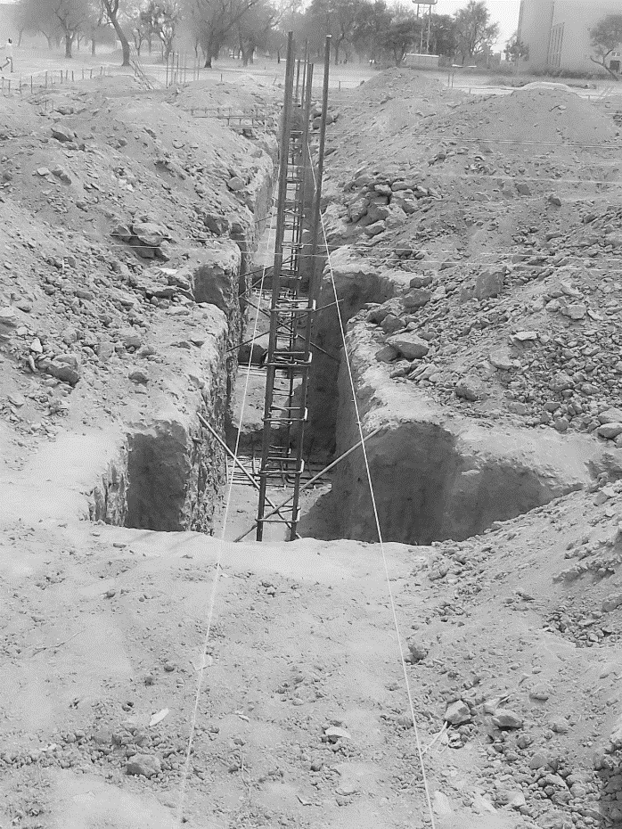
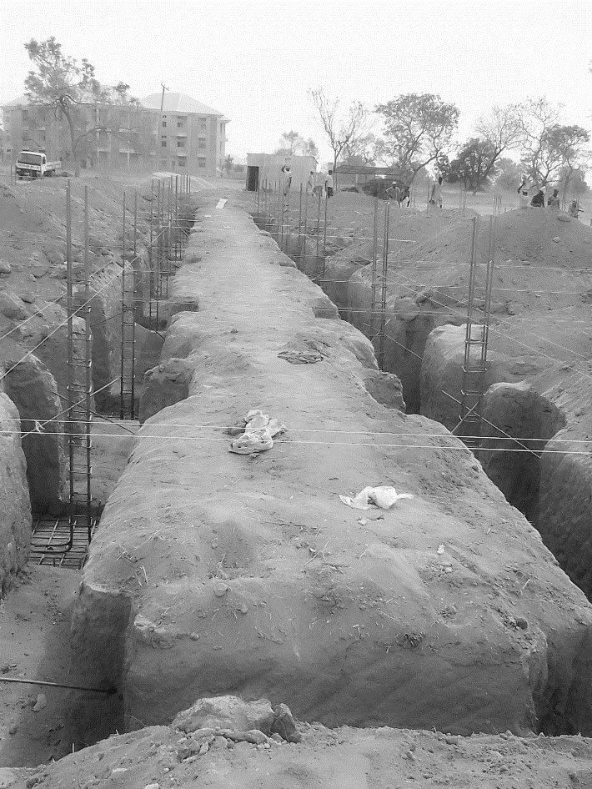
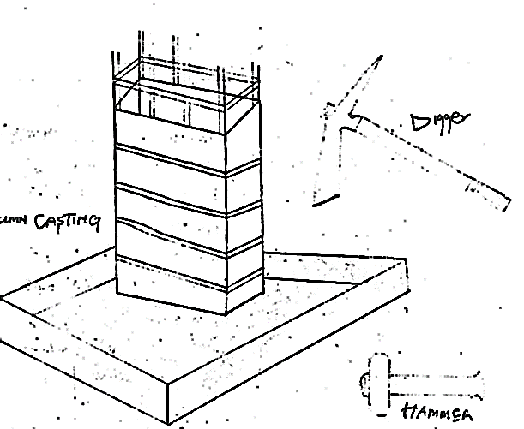
Plate 3.3: Column casting
Source: Author’s work, 2024

CHAPTER THREE

3.1 BLINDING
The mixture of sand, cement, gravel and water has taken place, the rope has been tight to the depth of 4 to 6 inches.
Then the concrete miture being usual to fill to the rope level. Usually blending is done so that to hold building to the ground, blending is mostly known as foundation footing.
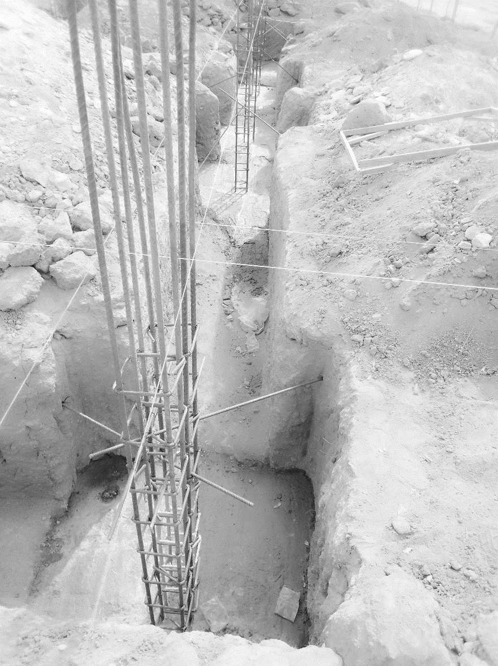
Plate 3.4: Blinding
Source: Author’s work, 2024

3.2 CASTING
Casting is a fundamental process in construction, involving the pouring of concrete into molds or formwork to create various structural elements. This section involves the casting procedures carried out for down beams, lintels, upper beams, and floors.
3.2.1 Casting of down beam
- Formwork was prepared and set up according to specifications.
- Reinforcement was placed within the formwork.
- Concrete was poured into the mold and vibrated for compaction.
- The cast down beam was left to cure before the formwork was removed.
- Any surface imperfections were addressed through finishing techniques.
3.2.2 Casting of Lintel
- Formwork was erected, and reinforcement was installed.
- Concrete was poured into the formwork and compacted.
- After curing, the formwork was stripped, revealing the cast lintel.
- Finishing touches were applied to achieve the desired appearance and dimensions.
3.2.3 Casting of Upper Beam
- Formwork was prepared, and reinforcement was placed.
- Concrete was poured into the formwork and compacted.
- The cast upper beam was allowed to cure before the formwork was removed.
- Finishing techniques were employed to address any surface imperfections.
3.2.4 Casting of Floor
- The subbase was prepared, and formwork was installed around the perimeter.
- Reinforcement was placed within the formwork.
- Concrete was poured onto the prepared subbase and leveled.
- After curing, the formwork was removed, revealing the finished floor surface.
- Surface protection measures were implemented to safeguard the newly cast floor.
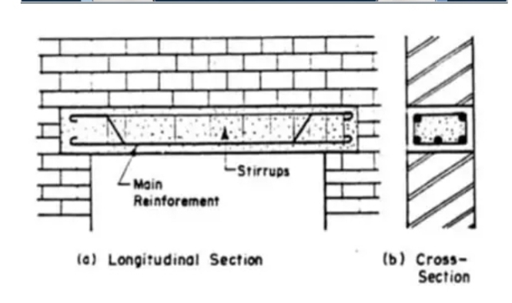
Plate 3.5: Casting of lintel

3.3 BLOCK WORK
Block laying is the process of arranging and securing individual blocks or bricks in a specific pattern to construct walls, partitions, or other structural elements in buildings or civil engineering projects. Blocks were moulded in number of sizes various composition, strength and shapes as 9 inches and 6 inches. Where the 9 inches were used for external walls, 6 inches for internal walls. After foundation work is finished the block work was built to cover the spaces as well. All the block work is not carrying any load, they were erected to cover spaces and also partition wall.
PROCEDURE
- Before starting the block laying process, the site was prepared by clearing debris and ensuring a level foundation.
- The layout of the walls or structure was marked using chalk lines or strings to guide the placement of the blocks.
- Blocks or bricks were selected based on the desired strength, size, and aesthetic requirements of the project.
- Mortar was mixed according to the specifications, typically using a combination of cement, sand, and water.
- A layer of mortar was spread evenly along the foundation where the first course of blocks would be placed.
- A level was used to check the horizontal and vertical alignment of the blocks.
- Once the first course was laid, additional courses of blocks were added on top, following the same process.
- Each block was buttered with mortar on its ends before being placed to ensure a strong bond between the blocks.
- Blocks may have needed to be cut to fit around corners, openings for doors or windows, or to maintain the desired pattern.
- Excess mortar was scraped off the joints using a trowel, and any gaps or voids were filled to create a smooth, uniform surface.
- Once the block laying was complete, the work area was cleaned up, and any excess materials or debris were removed from the site.
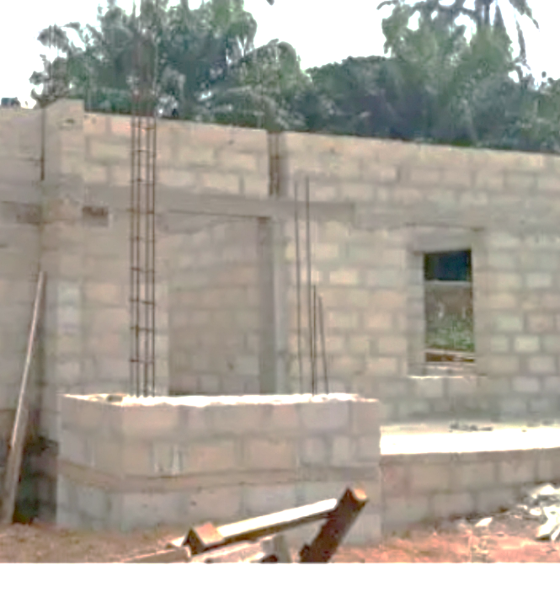
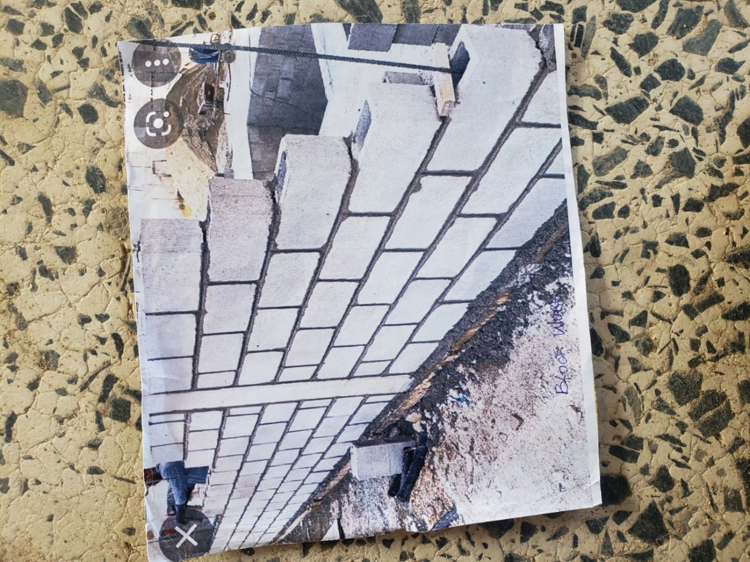
Plate 3.6: Block work
Source: Author’s work, 2024

3.4 CONSTRUCTION OF DRAINAGE REINFORCEMENT
Drainage reinforcement involves the process of strengthening drainage structures to ensure durability, stability, and resistance to erosion or structural failure. Reinforced drainage systems are crucial in managing water flow, preventing flooding, and maintaining the integrity of surrounding structures. The reinforcement process typically includes the use of steel bars, concrete, and other strengthening materials to enhance the load-bearing capacity of the drainage channels.

PROCEDURE
- Site Preparation – The drainage path was cleared of debris, vegetation, and loose soil to provide a stable foundation for construction.
- Excavation – The trench for the drainage system was excavated to the required depth and width, ensuring proper slope and alignment for efficient water flow.
- Formwork Installation – Wooden or steel formworks were set up along the trench to shape the reinforced concrete structure and maintain alignment during the pouring process.
- Steel Reinforcement Placement – Reinforcing bars (rebars) were cut, bent, and arranged according to the design specifications. The bars were tied together using binding wire to create a reinforcement framework within the drainage channel.
- Concrete Mixing – Concrete was prepared using a mix of cement, sand, gravel, and water in the appropriate proportions to achieve the desired strength.
- Concrete Pouring – The mixed concrete was poured into the trench and around the steel reinforcement, ensuring full coverage and compaction to eliminate air pockets.
- Leveling and Finishing – A trowel was used to smooth the surface, and any excess concrete was removed to maintain the desired shape and gradient.
- Curing – The reinforced drainage structure was kept moist for several days to ensure proper hydration of the concrete, allowing it to achieve maximum strength.
- Inspection and Cleanup – Once the concrete had set, the formwork was removed, and the site was cleaned of any construction debris. A final inspection was conducted to ensure structural integrity and proper drainage function.

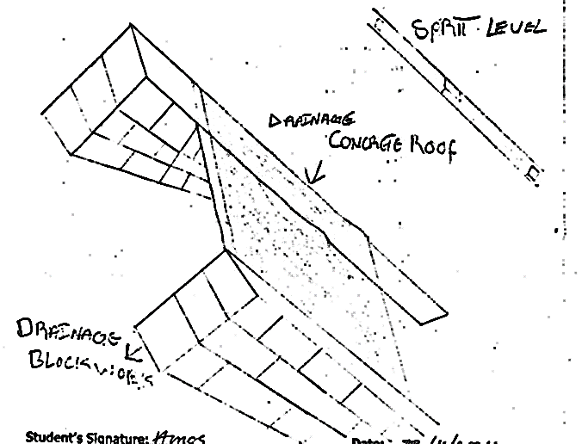

Plate 3.7: Drainage Reinforcement
Source: Author’s work, 2024

3.5 WORKING DRAWING ON SITE
During my SIWES, I was able to design an Administrative floor plan and Ground Floor plan. Fine attached.
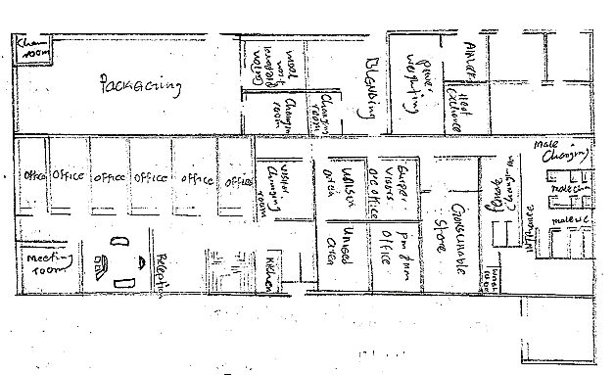
Plate 3.8: Administrative Ground floor
Source: Author’s work, 2024

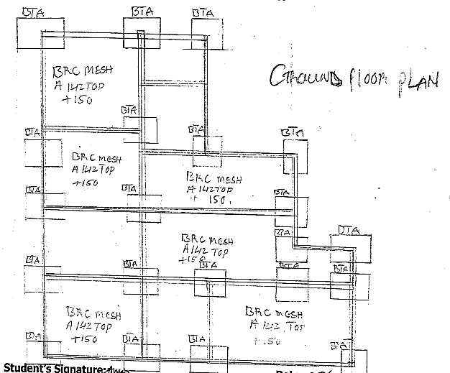

Plate 3.9: Ground floor plan
Source: Author’s work, 2024

CHAPTER FOUR

CONCLUSION AND RECOMMENDATIONS

4.1 CONCLUSION
The student industrial work experience scheme (SIWES) programme has expose me to bridge the gap between theoretical and practical aspect in civil engineering work. It also shaped me in acquiring knowledge and skills from the firm furthermore, it allows me to exercise my human relationship in the society by preparing me for meaningful and productive employment in future.

4.2 RECOMMENDATIONS
The following are the recommendations made;
- The industry should provide accommodation and also ensure that the health and security of the students on industrial attachment is provided.
- The government should increase the SIWES allowance and should be paid on time after the industrial attachment.
- The programme should continue from generation to generation respectively.

REFERENCE
Arthur, W., Peter, S. & Roy, A. (2013). Roadwork Theory & Practice, 2ND Edition, Mc Graw Hill, New York.
Bungey, J. H. & Mosley, W. (1990). Reinforced concrete design. Macmillan press London, fourth edition.
Burgen, T. & Mosely, W. (1990). Reinforced Concrete Design, Macmillan Press Limited, London, PP 275-569.
Neil, J. & Ravidra, K. (1996). Civil Engineering material. Macmillan press London Limited fourth edition.

